CSS BRITISH HISTORY · TOPIC 9 · QUESTION ANSWERS
Thatcher and Major (1979–1997)
Every past question on Thatcher, the Falklands, John Major and Britain and Europe — answered in full, in simple words, with answer maps

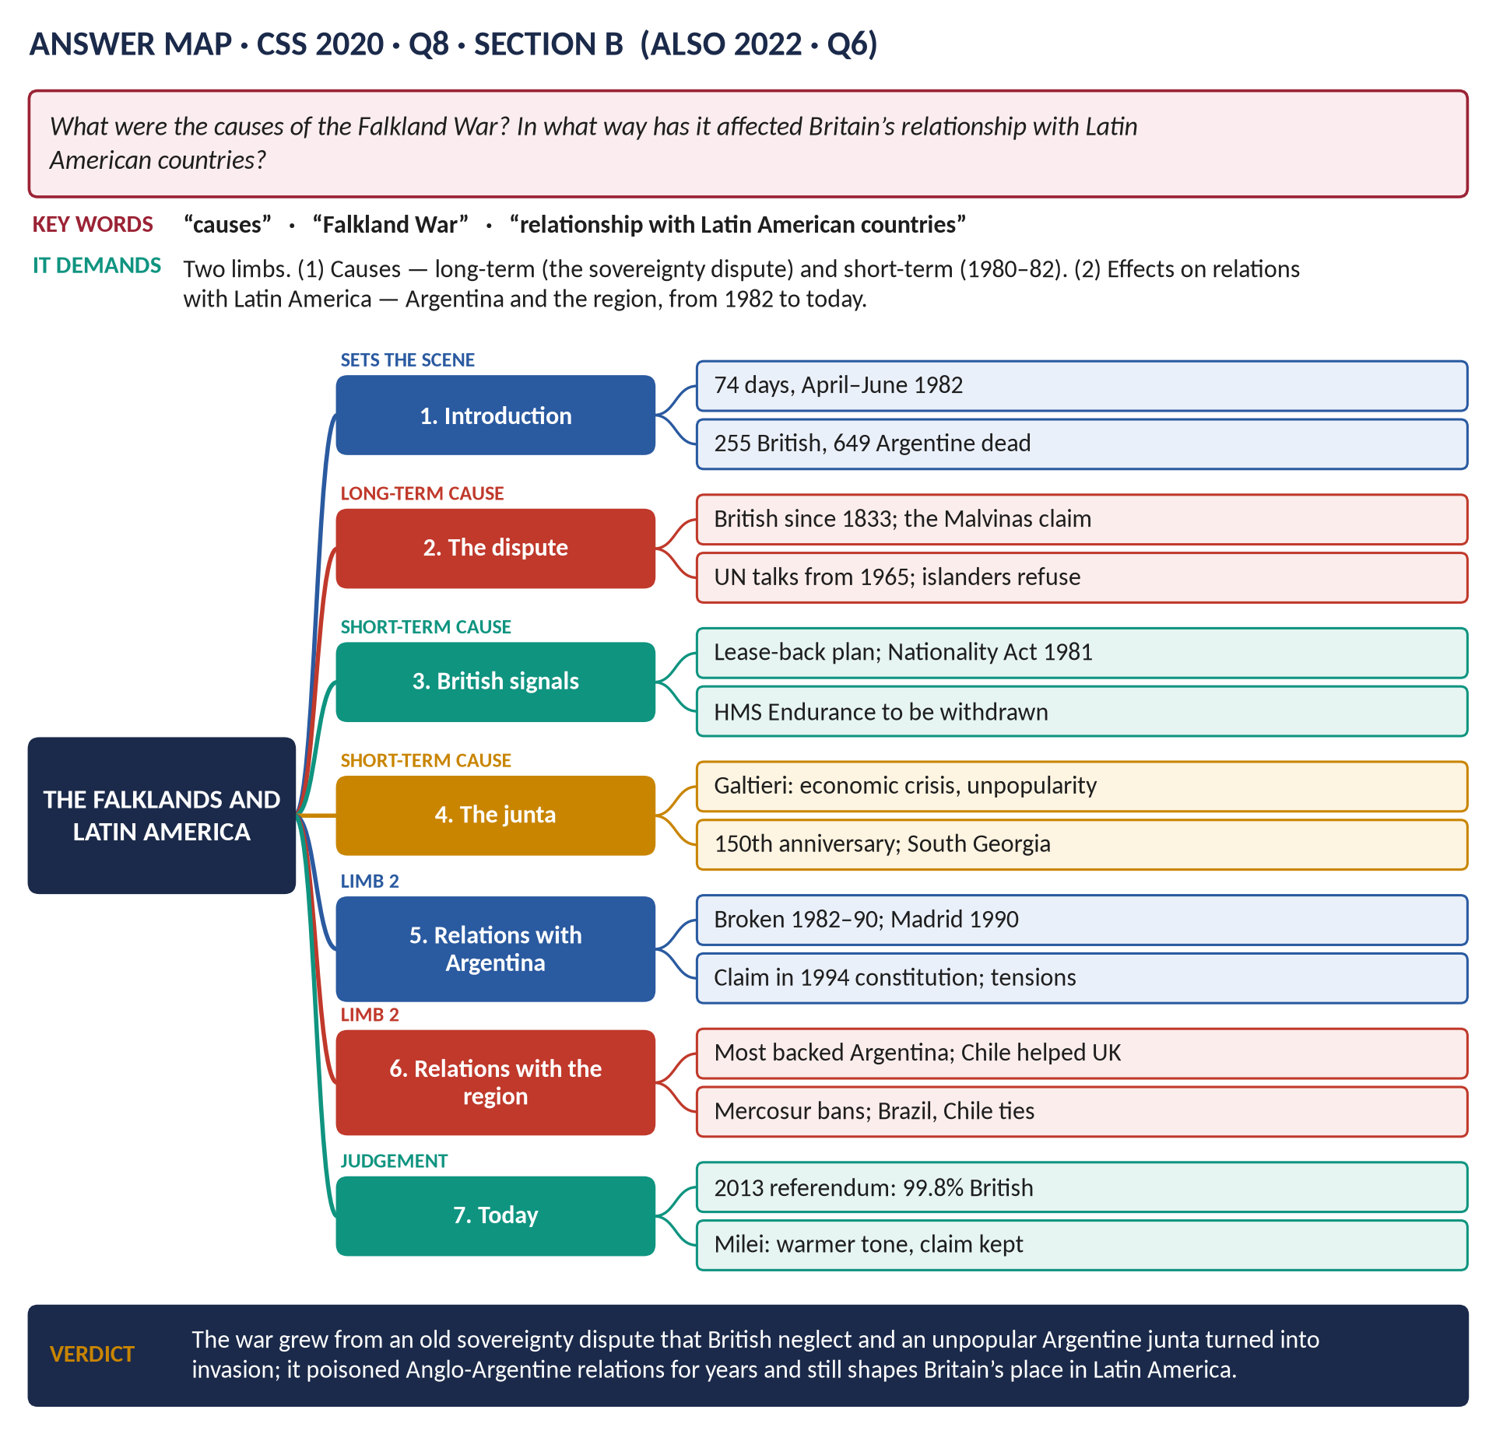
All 11 past items (2015–2026): seven full answers, one repeat shown with its adaptation, and three short notes; the four past MCQs solved; five predicted questions with outlines.
Topic 9 of 10 · companion to T9KB (the Knowledge Base)
Contents
HOW TO USE THIS · Updating the contents
Right-click the contents → Update Field → Update entire table, before saving as PDF.

How to Use These Answers 7
Answer 1 · Thatcher: The Best Post-War Prime Minister? 8
The model answer 9
Introduction 9
(1) The criteria for "best" 9
The case for 9
(2) She reversed Britain's decline 9
(3) She widened ownership 9
(4) Leadership and electoral success 10
(5) World stature 10
(6) Lasting impact 10
The case against 10
(7) The social cost 10
(8) Mistakes 10
(9) Division 10
Comparison with other post-war Prime Ministers 11
Answer 2 · Thatcherism: Economic and Educational Reforms and Their Impact 12
The model answer 13
Introduction 13
Part 1 · Defining Thatcherism 13
(1) Definition 13
(2) Its main elements 13
Part 2 · The economic reforms 14
(3) Monetarism and tax reform 14
(4) Privatisation 14
(5) Deregulation 14
(6) Trade-union reform 14
(7) Housing and local government 14
Part 3 · The educational reforms 14
(8) The GCSE 14
(9) The Education Reform Act (1988) 15
(10) The ideas behind them 15
Part 4 · The impacts on people's lives 15
(11) Positive impacts 15
(12) Negative impacts 15
Answer 3 · The Causes of the Falklands War and Its Effect on Relations with Latin America 17
The model answer 18
Introduction 18
Limb 1 · The causes 18
(1) The long-term cause: the sovereignty dispute 18
(2) Short-term cause: British signals of weakness 19
(3) Short-term cause: the Argentine junta 19
(4) The trigger 19
Limb 2 · The effect on relations with Latin America 19
(5) Argentina — broken and restored relations 19
(6) Argentina — renewed tension (2003–2015) 20
(7) Argentina — cautious improvement (2015–2026) 20
(8) The wider region 20
(9) Overall assessment 20
Answer 4 · The Same Question, Set Again 22
How to reuse Answer 3 22
Answer 5 · The Falkland Islands Conflict: What, Why and How It Ended 23
The model answer 24
Introduction 24
Part 1 · What was the conflict? 24
(1) The islands and the dispute 24
(2) The Argentine invasion 24
(3) The two sides 24
Part 2 · Why Britain sent forces to retake the islands 25
(4) Self-determination 25
(5) International law — aggression must not pay 25
(6) National pride and credibility 25
(7) Political pressure and leadership 25
(8) It was militarily possible 25
Part 3 · How the war came to an end 25
(9) Diplomacy fails (April–May) 25
(10) The war at sea and in the air 25
(11) The land campaign 26
(12) The surrender 26
(13) The immediate aftermath 26
Answer 6 · Why Major Won in 1992 but Lost in 1997 27
The model answer 28
Introduction 28
Why the Conservatives won in 1992 28
(1) A new leader 28
(2) Fear of Labour's taxes 28
(3) Doubts about Neil Kinnock 29
(4) Economic trust 29
(5) The "shy Tories" 29
Why the Conservatives lost in 1997 29
(6) Black Wednesday — the loss of economic credibility 29
(7) Broken promises on tax 29
(8) Division over Europe 29
(9) Sleaze 30
(10) Other problems 30
(11) New Labour 30
Linking the two elections 30
Answer 7 · Britain's Contribution to the Common Market and the European Union 32
The model answer 33
Introduction 33
Limb 1 · Britain's contribution 33
(1) Inspiration and early building (1946–1955) 33
(2) Standing aside from the Common Market (1950–1972) 34
(3) Contributions as a member (1973–1992) 34
(4) Maastricht and the creation of the European Union (1991–1993) 34
(5) Later contributions (1997–2016) 35
Limb 2 · The impact on British foreign policy 35
(6) From empire to Europe 35
(7) A bridge between America and Europe 35
(8) Pooled powers 35
(9) The "awkward partner" 35
(10) After Brexit (2020–2026) 35
Answer 8 · European Integration and British Politics and Identity since 1973 37
The model answer 38
Introduction 38
Politics, 1973–1990 38
(1) Labour's divisions 38
(2) Thatcher and Europe 38
(3) Sovereignty in law 38
The Maastricht debates (1991–1993) 39
(4) What Maastricht did 39
(5) Major's opt-outs 39
(6) The ratification crisis 39
(7) New Eurosceptic politics 39
The euro opt-out 39
(8) Black Wednesday and the euro 39
(9) Blair and Brown 39
(10) Why the opt-out mattered 40
From Maastricht to Brexit (2004–2020) 40
(11) The road to the referendum 40
The impact on identity 40
(12) "British, not European" 40
(13) Sovereignty 40
(14) A divided nation 40
Summary of the impact 41
Short Notes 42
Britain's Role in the European Union 42
The Falklands War (1982) 42
John Major's Foreign Policy (1990–1997) 43
Part Two — The Past MCQs, Solved 44
CSS 2024 · MCQ 9 44
CSS 2025 · MCQ 14 44
CSS 2025 · MCQ 19 44
CSS 2026 · MCQ 10 44
Part Three — Five Predicted Questions, with Outlines 46
Predicted 1 · "Discuss the causes, course and consequences of the miners' strike of 1984–85." 46
Predicted 2 · "Why did Margaret Thatcher fall from power in 1990?" 46
Predicted 3 · "Assess Thatcher's foreign policy, with reference to the USA, the Soviet Union and Europe." 46
Predicted 4 · "Trace the Northern Ireland peace process from 1979 to 1998." 46
Predicted 5 · "How far did Thatcherism end the post-war consensus?" 46

How to Use These Answers
# | Paper | Question (short) | Answer
1 | 2016 Q6 | "Thatcher the best post-war Prime Minister" — discuss | Answer 1
2 | 2024 Q5 | Define Thatcherism; her economic and educational reforms and their impact | Answer 2
3 | 2020 Q8 | Causes of the Falklands War; effect on relations with Latin America | Answer 3
4 | 2022 Q6 | The same question as 2020 — how to reuse Answer 3 | Answer 4
5 | 2021 Q6 | What was the Falklands conflict; why Britain fought; how it ended | Answer 5
6 | 2019 Q8 | Why Major won in 1992 but lost in 1997 | Answer 6
7 | 2021 Q7 | Britain's contribution to the Common Market and EU; impact on foreign policy | Answer 7
8 | 2026 Q6 | European integration and British politics and identity since 1973 | Answer 8
9 | 2018 Q8(b) | Short note: Britain's role in the EU | Short note
10 | 2024 Q7(a) | Short note: the Falklands War | Short note
11 | 2026 Q8(c) | Short note: John Major's foreign policy | Short note

Every answer has: the question as set · its answer map · decoding the question · a model answer with numbered headings, figures and a verdict · why this answer scores.
TRAP — DO NOT FALL INTO IT · The Falklands, four ways
Causes and Latin America (2020, 2022 — identical), what, why and how it ended (2021), and a short note (2024). The facts are in T9KB Chapter 2; the headings must come from each question.

Answer 1 · Thatcher: The Best Post-War Prime Minister?
THE QUESTION · CSS 2016 · Q6 · Section B · 20 marks
'Margaret Thatcher is judged to be the best post-war Prime Minister of England.' Discuss.

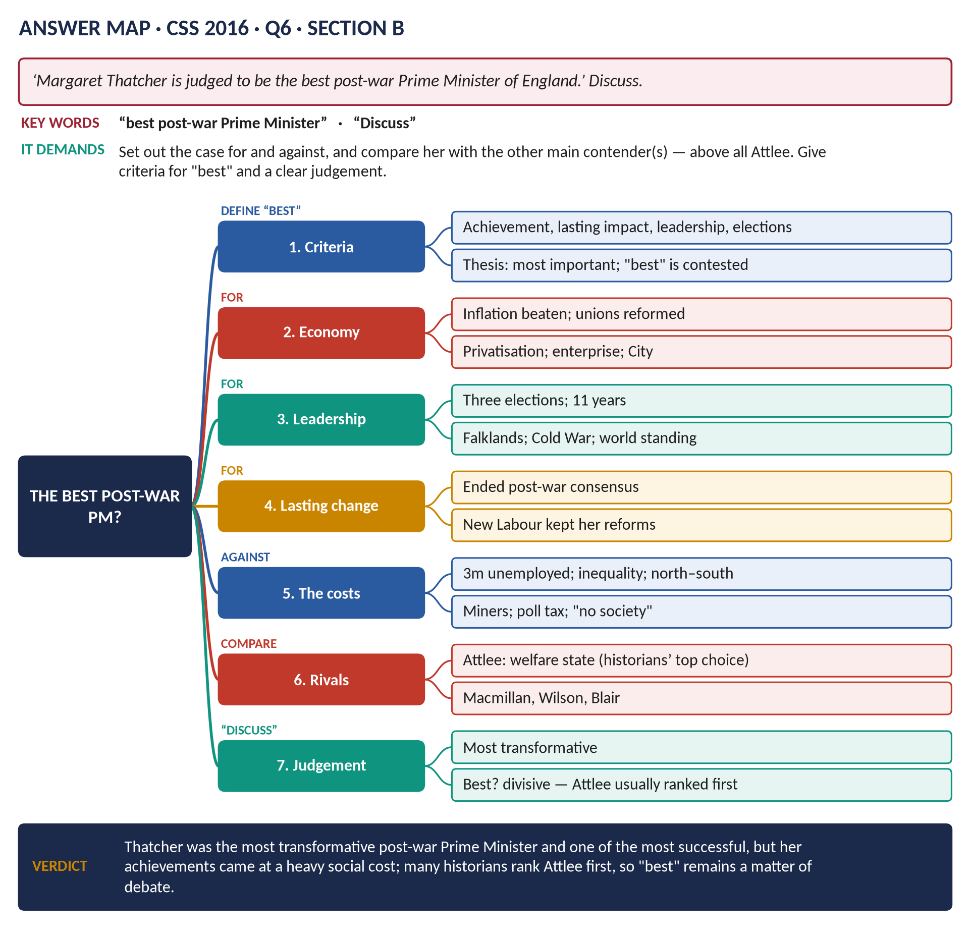
Figure 1 · The answer map for CSS 2016 · Q6 · Section B: every branch is one heading of the answer below.
DECODING THE QUESTION
"Discuss" a claim: give the case for and the case against, compare Thatcher with other post-war Prime Ministers (especially Attlee), set criteria for "best", and end with a clear judgement. "Post-war" = since 1945.

The model answer

Introduction
Margaret Thatcher, Prime Minister from 1979 to 1990, was Britain's first woman Prime Minister, the longest-serving of the twentieth century, and the only one whose name became an "-ism". Her admirers call her the best post-war Prime Minister; her critics call her the most divisive. Judged by achievement, lasting impact, leadership and electoral success, she has a strong claim to be the most important and transformative post-war leader. Whether she was the best is more doubtful: her gains came at a heavy social cost, and most historians place Clement Attlee first.

(1) The criteria for "best"
1. What did the Prime Minister achieve?
2. How lasting were the changes?
3. How strong was the leadership, at home and abroad?
4. How successful electorally?
5. At what cost?

The case for

(2) She reversed Britain's decline
- In 1979 Britain was the "sick man of Europe": inflation, strikes (the Winter of Discontent), loss-making state industries.
- Inflation fell from about 22 per cent (1980) to under 5 per cent (1983).
- Union reform (1980, 1982, 1984) and the defeat of the miners' strike (1984–85) ended the strikes that had brought down two governments.
- Privatisation (BT, British Gas, British Airways, water) and the Big Bang (1986) created a more efficient, enterprising economy; London became a world financial centre.
- Tax cuts: the top rate of income tax fell from 83 to 40 per cent.

(3) She widened ownership
- Right to Buy (1980): over a million council tenants bought their homes; home ownership rose to about two-thirds.
- Shareholders rose from about 3 to about 11 million.

(4) Leadership and electoral success
- Three general election victories (1979, 1983, 1987) and 11½ years in office — the longest continuous term since 1827.
- Conviction and courage: "The lady's not for turning"; she survived the Brighton bomb (1984).

(5) World stature
- The Falklands (1982): she retook the islands and restored national pride.
- The Cold War: Reagan's closest ally; she saw in Gorbachev a man to "do business" with, helping to end the Cold War peacefully.
- Europe: the budget rebate (1984); the single market (1986).

(6) Lasting impact
She ended the post-war consensus and created a new one: Tony Blair's New Labour kept privatisation, the union laws and low income taxes. No other post-war PM, except Attlee, changed Britain so permanently.

The case against

(7) The social cost
- Unemployment over 3 million for five years (1982–87); whole industrial communities destroyed — coal, steel, shipbuilding.
- Inequality rose faster than in almost any other developed country; poverty grew; a north–south divide.
- Riots (Brixton, Toxteth, 1981) and the bitterness of the miners' strike.
- "There is no such thing as society" (1987) seemed to sum up a selfish age.

(8) Mistakes
- The poll tax (1989–90) — unfair and unworkable; riots.
- Economic mismanagement at the end: the Lawson boom, inflation back to 10 per cent, 15 per cent interest rates.
- Housing: council houses sold but not replaced.
- Manufacturing neglected in favour of finance.

(9) Division
She divided the nation (the north v the south, Scotland v England) and her own party — her hostility to Europe led to the resignations of Lawson and Howe and to her fall (1990) at the hands of her own cabinet.

Comparison with other post-war Prime Ministers
Prime Minister | Claim to be "best"
Attlee (1945–51) | Built the welfare state and NHS, freed India, founded NATO — usually ranked first by historians.
Churchill (1951–55) | Great as a war leader; less so in peacetime.
Macmillan (1957–63) | Prosperity; decolonisation; restored the US alliance.
Wilson (1964–70, 1974–76) | Social reforms; won four elections.
Thatcher (1979–90) | Transformed the economy; three victories; Falklands; Cold War.
Blair (1997–2007) | Three victories; Northern Ireland peace; but Iraq.

Surveys of historians and political scientists (for example 2004, 2010, 2016) usually put Attlee first and Thatcher second.
VERDICT · Conclusion
Thatcher has a powerful claim to be the most important and transformative post-war Prime Minister: she defeated inflation and union power, remade the economy, won three elections and the Falklands War, and changed British politics so deeply that her opponents kept her reforms. But her success came at a heavy price in unemployment, inequality and division, and she ended her career rejected by her own party. "Best" therefore remains contested: she was the most transformative, but most historians still give first place to Attlee, whose welfare state was built with less division.

WHY THIS ANSWER SCORES · Why this answer scores
It sets criteria for "best" · gives a full case for and a full case against, with figures · compares her with other PMs (a table) and cites historians' rankings · reaches a nuanced verdict — "most transformative" v "best".

Answer 2 · Thatcherism: Economic and Educational Reforms and Their Impact
THE QUESTION · CSS 2024 · Q5 · Section B · 20 marks
Define the term 'Thatcherism'. Discuss Margaret Thatcher's economic and educational reforms and their impacts on people's lives.

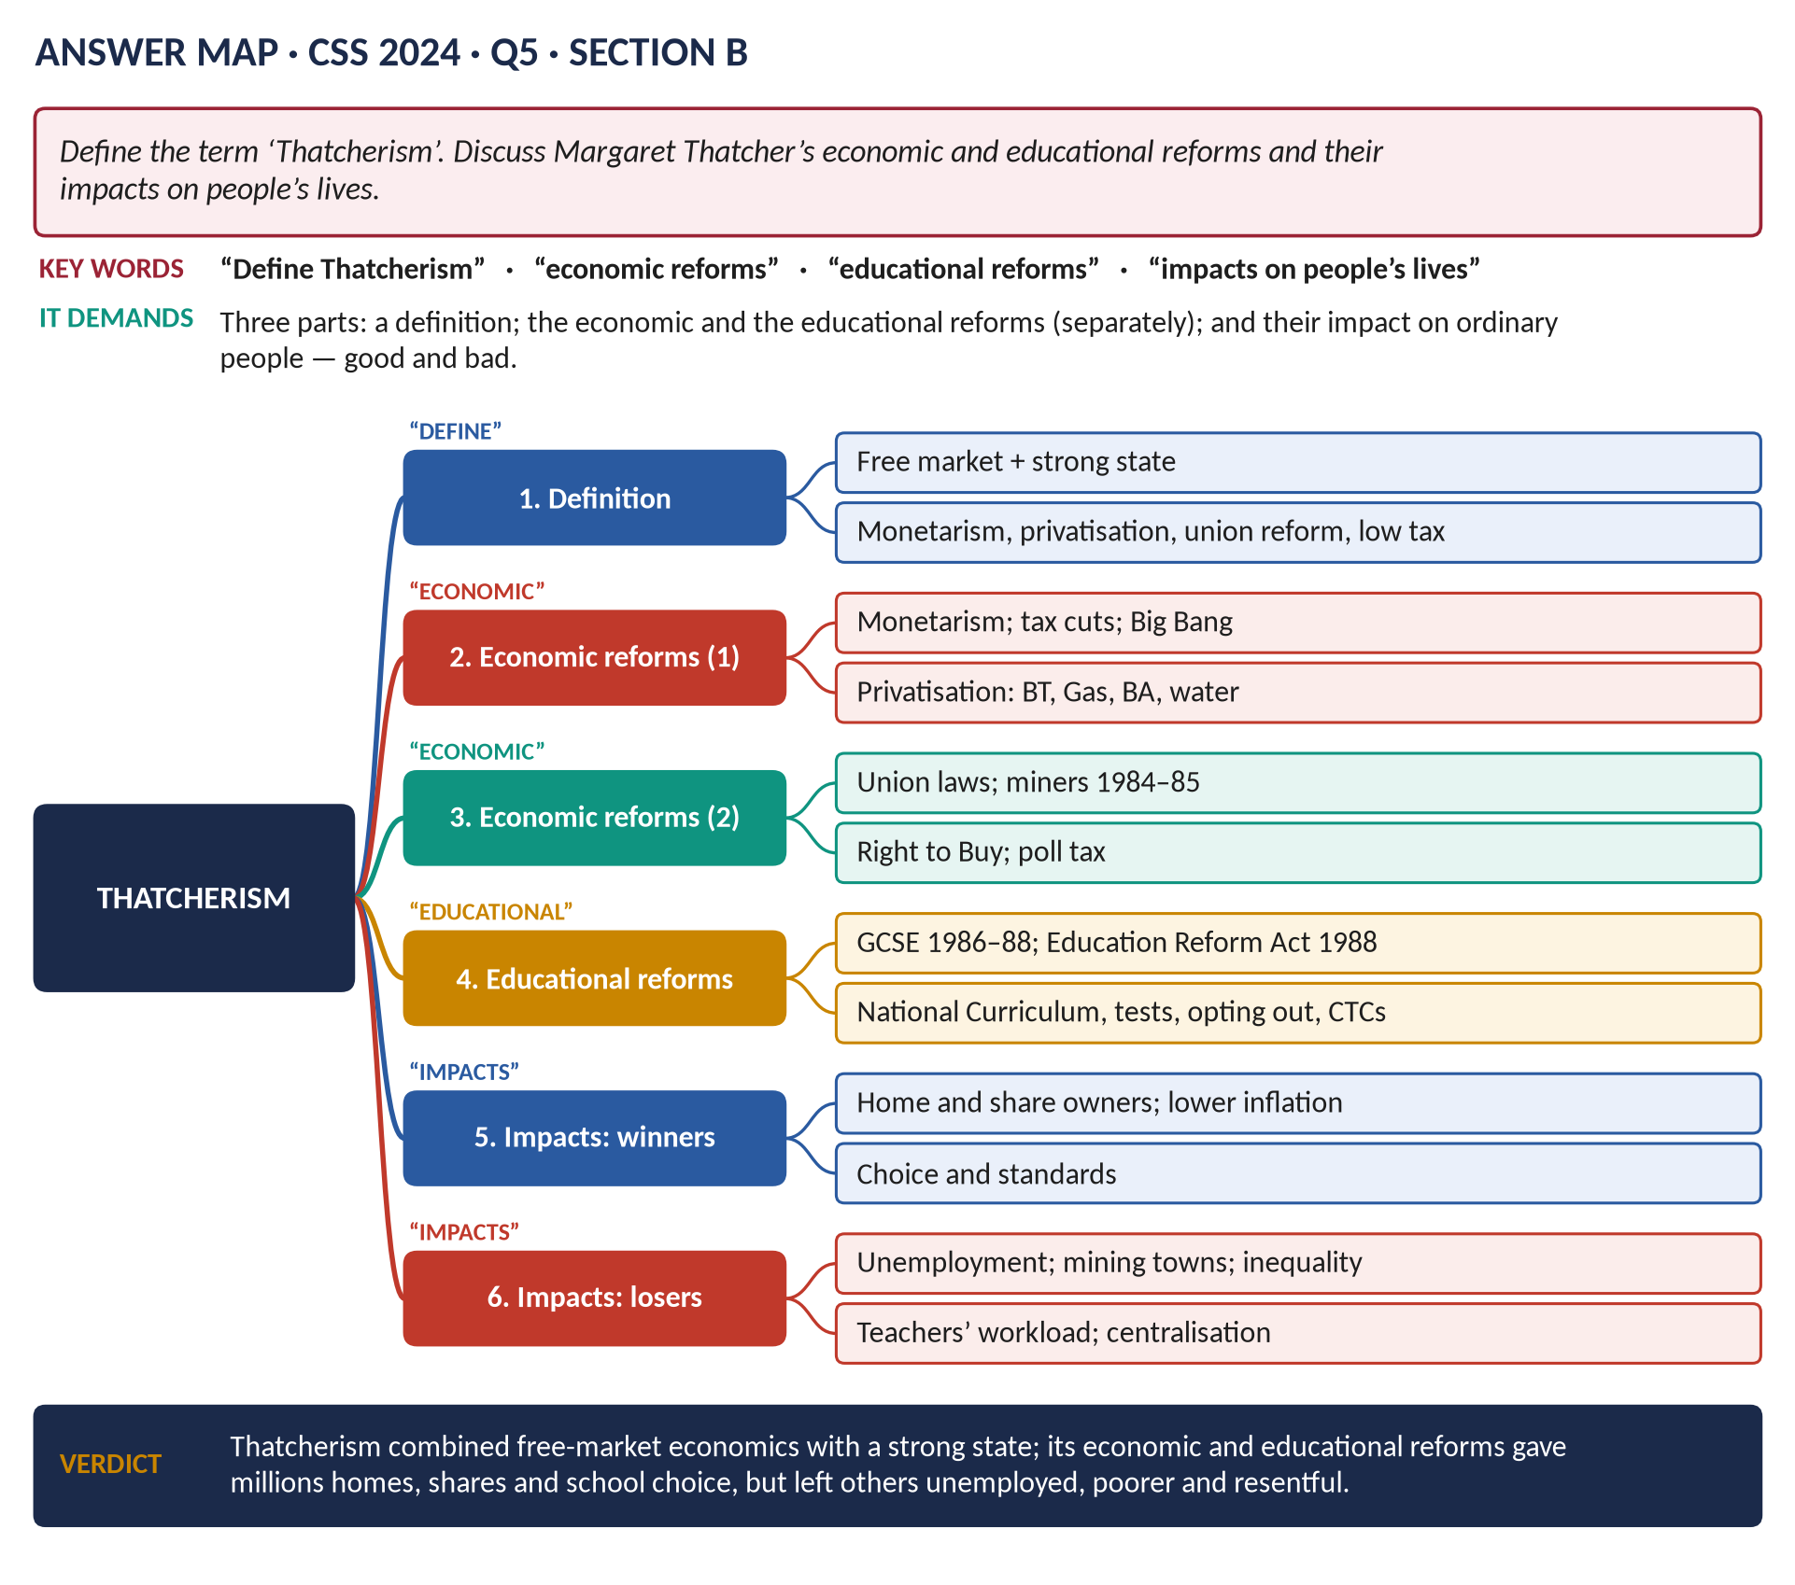
Figure 2 · The answer map for CSS 2024 · Q5 · Section B: every branch is one heading of the answer below.
DECODING THE QUESTION
Three parts. (1) "Define the term 'Thatcherism'" — a clear definition and its main elements. (2) "Discuss Margaret Thatcher's economic and educational reforms" — two kinds of reform, each with its own section. (3) "… and their impacts on people's lives" — how ordinary people were affected, good and bad.

The model answer

Introduction
Thatcherism is the name given to the political ideas and policies of Margaret Thatcher, Conservative Prime Minister from 1979 to 1990 — a combination of free-market economics and a strong state. Through it she set out to reverse Britain's economic decline and end the post-war consensus. Her economic reforms — monetarism, privatisation, tax cuts, union laws and the sale of council houses — and her educational reforms — the GCSE and the Education Reform Act of 1988 — changed the lives of millions: many gained homes, shares, jobs in new industries and choice in schooling; many others lost their jobs, their communities and their security.

Part 1 · Defining Thatcherism

(1) Definition
Thatcherism is the belief that Britain's prosperity depends on free markets, private enterprise and individual responsibility, protected by a strong state that keeps order, curbs the power of the unions and defends national interests — "the free economy and the strong state" (Andrew Gamble).
The term was coined by the writer Stuart Hall (1979).
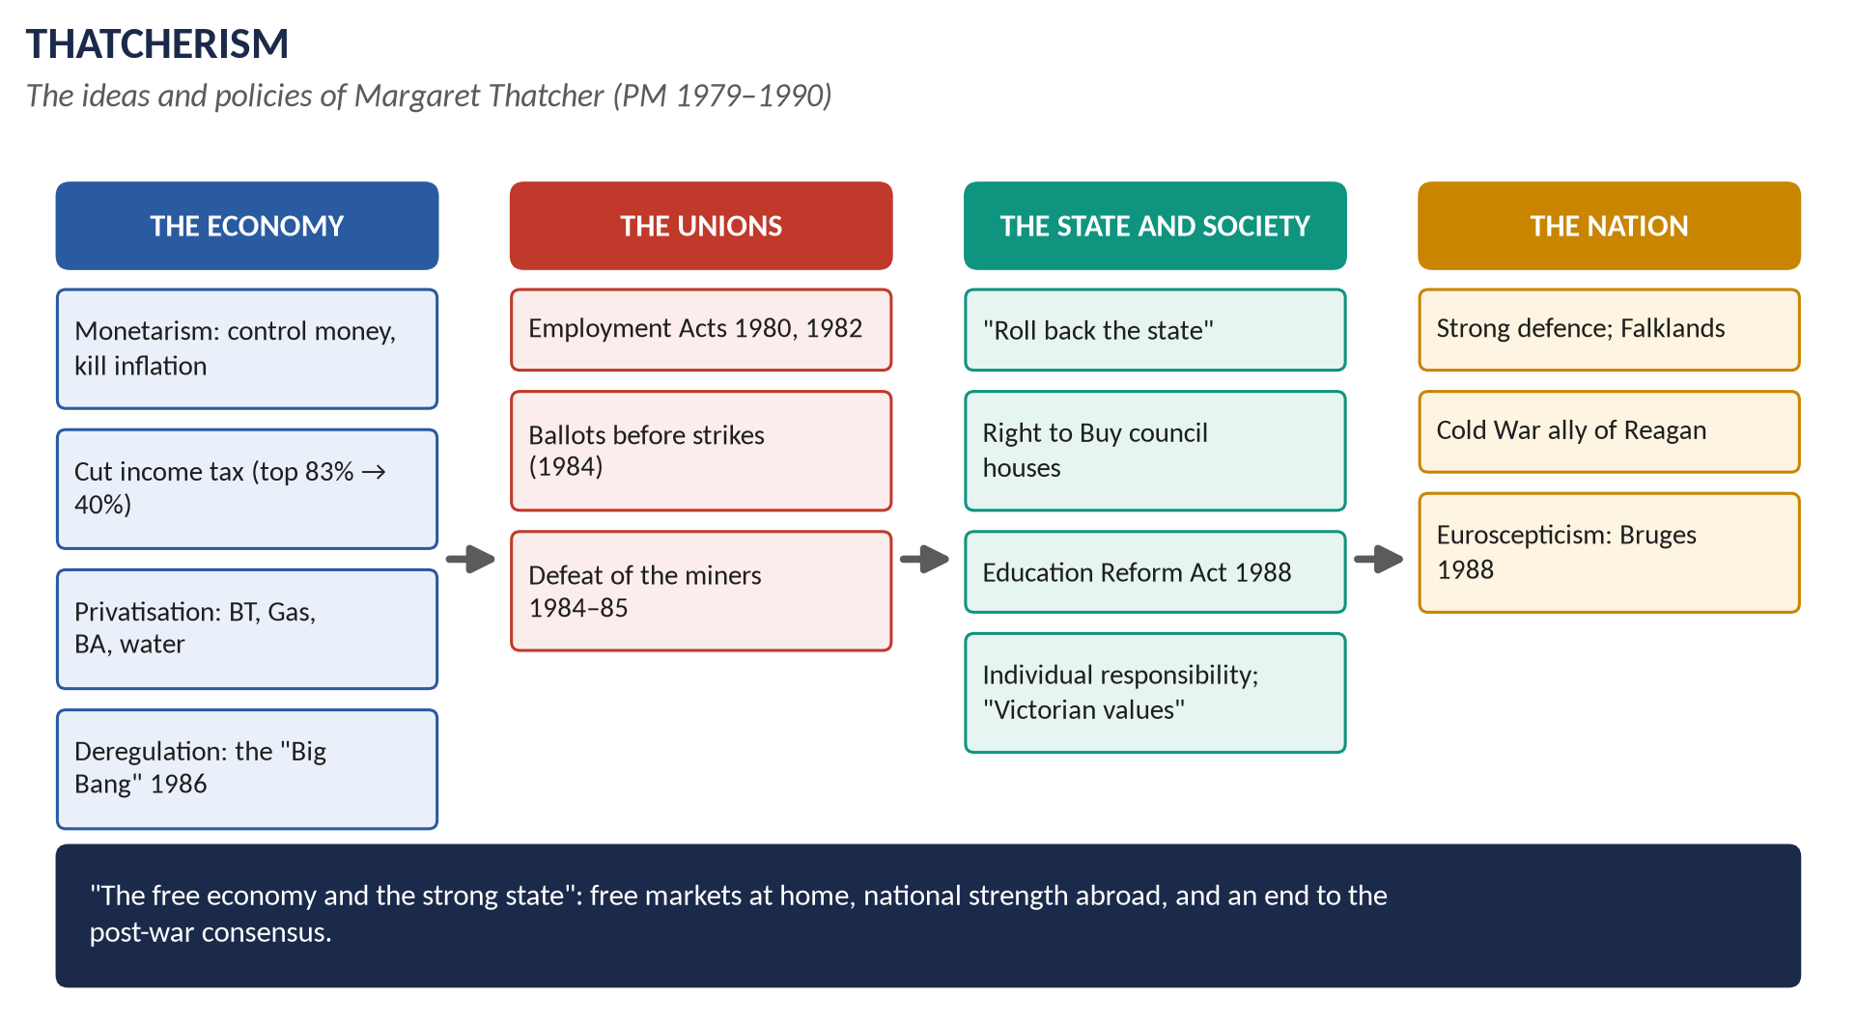
Figure 3 · The elements of Thatcherism.

(2) Its main elements
1. Monetarism (Milton Friedman): control the money supply to defeat inflation.
2. Free markets and privatisation (Friedrich Hayek).
3. Low taxes to reward enterprise.
4. A smaller state — "rolling back the frontiers of the state".
5. Curbing trade-union power.
6. Self-reliance, the family, "Victorian values".
7. A property-owning democracy.
8. Law and order, strong defence, national sovereignty (the Falklands; Euroscepticism).
9. Conviction politics instead of consensus.

Part 2 · The economic reforms

(3) Monetarism and tax reform
- Howe's budget (1979): income tax cut (top rate 83 → 60 per cent; basic rate 33 → 30); VAT raised to 15 per cent (a shift from taxing income to taxing spending); exchange controls abolished.
- High interest rates and spending cuts; the deep recession of 1980–81.
- Lawson (1988): top rate 40 per cent, basic rate 25 per cent.

(4) Privatisation
British Telecom (1984), British Gas (1986, "Tell Sid"), British Airways (1987), British Steel (1988), the water companies (1989), electricity (1990) — about £29 billion raised.

(5) Deregulation
The Big Bang (1986) in the City; credit and mortgage controls removed.

(6) Trade-union reform
- Employment Acts (1980, 1982): limits on picketing and the closed shop.
- Trade Union Act (1984): secret ballots before strikes.
- The miners' strike (1984–85) defeated; pit closures followed.

(7) Housing and local government
- The Right to Buy (Housing Act 1980).
- The GLC abolished (1986); the poll tax (1989–90).

Part 3 · The educational reforms

(8) The GCSE
Announced in 1984, first taught in 1986, first examined in 1988: one exam for all 16-year-olds, replacing O-levels and CSEs, with more coursework.

(9) The Education Reform Act (1988)
Passed by Kenneth Baker — the biggest reform since 1944:
1. The National Curriculum: core subjects (English, maths, science) and foundation subjects for all state schools in England and Wales.
2. National tests ("SATs") at 7, 11 and 14.
3. Local Management of Schools: budgets given to heads and governors.
4. Grant-maintained schools: schools could opt out of local-authority control.
5. City Technology Colleges, with business sponsors.
6. Open enrolment and parental choice (league tables followed in 1992).
7. The Inner London Education Authority abolished; university tenure ended.

(10) The ideas behind them
Higher standards, choice and competition between schools, accountability to parents, and less power for local authorities and teachers' unions.

Part 4 · The impacts on people's lives

(11) Positive impacts
1. Lower inflation: savings and wages kept their value.
2. Home ownership: over a million council tenants bought their homes.
3. Share ownership: about 11 million shareholders by 1990.
4. Lower income tax: more take-home pay, especially for higher earners.
5. New jobs and wealth in finance, services and the south-east; consumer spending rose.
6. Better services in some privatised industries (a phone line in days, not months).
7. Education: a common curriculum for every child; clear information for parents; more choice; more young people stayed on after 16.

(12) Negative impacts
1. Unemployment: over 3 million (1982–87); mass redundancies in coal, steel, shipbuilding and manufacturing.
2. Destroyed communities: mining villages and industrial towns in the north, Scotland and Wales.
3. Inequality: the gap between rich and poor widened sharply; child poverty rose.
4. Higher VAT and the poll tax fell heavily on the poor.
5. Housing shortage: council houses sold but not replaced; later homelessness.
6. Education: heavy testing, teacher workload and strikes, more central control, bigger gaps between popular and struggling schools.
VERDICT · Conclusion
Thatcherism — free markets within a strong state — was carried out through far-reaching economic reforms (monetarism, tax cuts, privatisation, union laws, Right to Buy) and educational reforms (the GCSE and the Education Reform Act of 1988). Their impact on people's lives was deeply divided: millions gained homes, shares, lower taxes, lower inflation and more choice in schools, while millions of others lost their jobs and communities and saw inequality grow. That division is why Thatcher remains both the most admired and the most disliked Prime Minister of modern times.

WHY THIS ANSWER SCORES · Why this answer scores
A boxed definition and its elements · economic and educational reforms in separate sections, with dates and figures · the impacts set out as positive and negative, as the question requires · a balanced conclusion.

Answer 3 · The Causes of the Falklands War and Its Effect on Relations with Latin America
THE QUESTION · CSS 2020 · Q8 · Section B · 20 marks
What were the causes of the Falkland War? In what way has it affected Britain's relationship with Latin American countries?

Figure 4 · The answer map for CSS 2020 · Q8 · Section B: every branch is one heading of the answer below.
DECODING THE QUESTION
Two limbs. (1) "What were the causes of the Falkland War?" — the long-term cause (the sovereignty dispute) and the short-term causes (British signals and the Argentine junta's motives). (2) "In what way has it affected Britain's relationship with Latin American countries?" — Argentina in particular and the region in general, from 1982 to today.

The model answer

Introduction
The Falklands War (2 April – 14 June 1982) was fought between Britain and Argentina over the Falkland Islands (Las Malvinas), a British territory in the South Atlantic with about 1,800 inhabitants of British descent. Argentina invaded; Britain sent a task force and retook the islands in 74 days, at the cost of 255 British and 649 Argentine lives. The war grew from an old sovereignty dispute, turned into war by British signals of indifference and the political needs of Argentina's military junta. It damaged Britain's relations with Argentina for years and left a lasting irritant in its relations with Latin America.
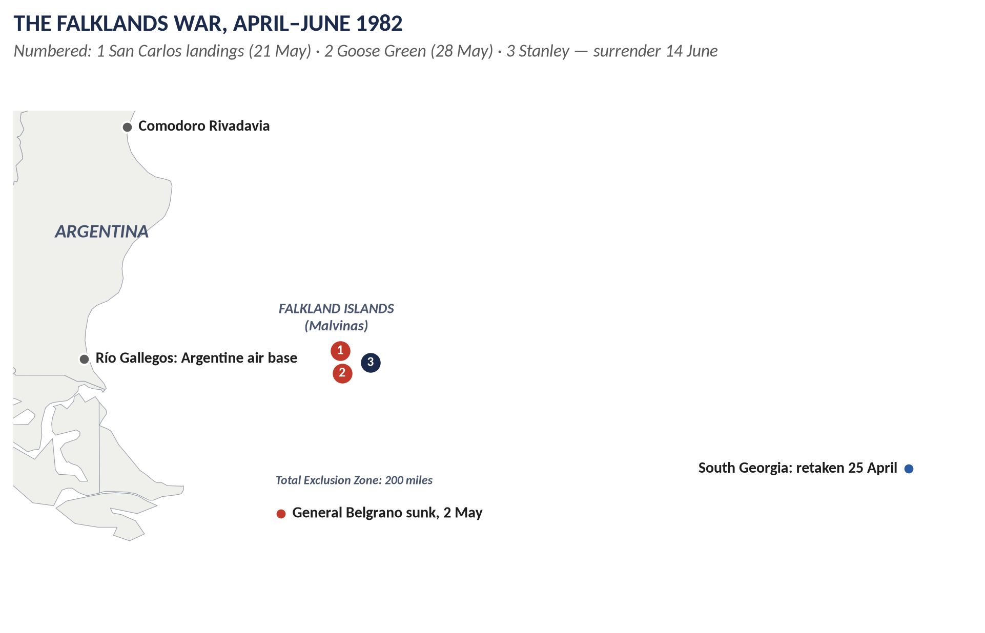
Figure 5 · The Falklands War.

Limb 1 · The causes

(1) The long-term cause: the sovereignty dispute
- Rival claims: British, French and Spanish settlements in the 18th century. Argentina claims it inherited Spain's rights on independence (1816) and had a settlement there in the 1820s.
- 1833: Britain took control and expelled the Argentine garrison; British settlers followed. Argentina never accepted this.
- Argentine nationalism: every Argentine child learned that "las Malvinas son argentinas".
- The UN: Resolution 2065 (1965) called on the two countries to negotiate. Talks dragged on for 17 years.
- The islanders' veto: the islanders refused any transfer; Parliament supported them. Nicholas Ridley's "lease-back" plan (1980) was rejected.

(2) Short-term cause: British signals of weakness
1. The 1981 Defence Review (John Nott) announced the withdrawal of HMS Endurance, the only Royal Navy ship in the area.
2. The British Nationality Act (1981) denied the islanders full British citizenship.
3. Years of negotiation made the junta believe Britain did not really want the islands.
4. Britain ignored intelligence warnings in early 1982.

(3) Short-term cause: the Argentine junta
- General Leopoldo Galtieri's military government (from December 1981) faced an economic crisis (inflation over 100 per cent), mass protests and anger over the "Dirty War" — thousands of opponents "disappeared".
- A quick, popular victory would unite the nation behind the junta.
- Timing: the 150th anniversary of British rule (1983) was approaching; the British navy was being cut; it was the southern winter.
- Miscalculation: the junta believed Britain would not fight at a distance of 8,000 miles, and that the USA, which valued Argentina as an anti-communist ally, would stay neutral.

(4) The trigger
On 19 March 1982 Argentine scrap-metal workers landed on South Georgia and raised the Argentine flag. When Britain protested, the junta brought its invasion forward to 2 April 1982.
KEY IDEA · Weighing the causes
The sovereignty dispute made conflict possible; British neglect made it look safe; the junta's domestic crisis made it attractive. The decisive cause was the junta's choice to use force — based on the miscalculation that Britain would not respond.

Limb 2 · The effect on relations with Latin America

(5) Argentina — broken and restored relations
- 1982–1990: diplomatic relations were broken off; trade and flights stopped.
- The Madrid Declarations (1989–90) restored relations under a "sovereignty umbrella": both sides agreed to cooperate while keeping their claims.
- The 1990s: better relations under President Menem (Prince Charles visited in 1999; the islanders' ban on Argentine visitors was lifted).
- The 1994 Argentine constitution declared the claim to the islands "permanent and unrenounceable".

(6) Argentina — renewed tension (2003–2015)
- Presidents Néstor and Cristina Kirchner revived the claim: protests at the UN, restrictions on flights and shipping, anger at British oil exploration (from 2010) and fishing licences.
- The 2013 referendum: 99.8 per cent of islanders (1,513 to 3) voted to remain British — Argentina rejected it.

(7) Argentina — cautious improvement (2015–2026)
- President Macri (2015–19) sought cooperation (flights, identification of Argentine war dead buried on the islands, 2017–18).
- President Javier Milei (from December 2023) praised Thatcher and sought closer ties with Britain, while insisting the claim would be pursued peacefully.

(8) The wider region
1. Solidarity with Argentina: in 1982 most Latin American governments and the Organisation of American States backed Argentina, seeing Britain as a colonial power; many still support Argentina's claim at the UN and in regional bodies.
2. Mercosur (2011) agreed to close its members' ports to ships flying the Falklands flag.
3. Chile, Argentina's rival, secretly helped Britain in 1982 (intelligence, radar) and remains a close partner.
4. Brazil and Mexico have built strong trade ties with Britain despite supporting Argentina.
5. Suspicion of British military presence: the garrison and the Mount Pleasant base are criticised as "militarising" the South Atlantic.
6. Trade and cooperation: after Brexit Britain sought new trade in Latin America (e.g. the UK–Mercosur dialogue; CPTPP membership alongside Chile, Peru and Mexico).

(9) Overall assessment
The war made the Falklands a permanent irritant in Britain's relations with Latin America: relations with Argentina were broken for eight years and have swung between hostility and cooperation ever since, and the region generally sides with Argentina's claim. But pragmatic trade and diplomacy have grown, and no country has seriously threatened force again.
VERDICT · Conclusion
The Falklands War was caused by a century and a half of unresolved sovereignty dispute, made dangerous by British signals of indifference and turned into war by a failing Argentine junta that gambled on Britain not fighting. Its effect on Britain's relations with Latin America has been lasting: a break with Argentina until 1990, recurring tension over the islands, and broad regional sympathy for Argentina's claim — softened, but never removed, by growing trade and pragmatic cooperation.

WHY THIS ANSWER SCORES · Why this answer scores
The causes are layered — long-term, British signals, the junta, the trigger — and weighed in a key box · the effects cover Argentina in three phases (1982–90, 2003–15, 2015–26) and the region, with specific evidence (Madrid 1990, 1994 constitution, 2013 referendum, Mercosur, Chile) · a clear verdict.

Answer 4 · The Same Question, Set Again
THE QUESTION · CSS 2022 · Q6 · Section B · 20 marks
Explain the genesis of the Falkland War. How has it affected Britain's relationship with Latin American countries?

DECODING THE QUESTION
The full question: "Explain the genesis of the Falkland War. How has it affected Britain's relationship with Latin American countries?" This is 2020 Q8 (Answer 3) in different words: "genesis" means origins — how the war came about.

How to reuse Answer 3
1. Use "genesis" as your heading word: "The genesis of the war" — the long-term origins (1690–1965), the negotiations (1965–81), and the crisis (1981–82).
2. Tell it as a sequence rather than a list of causes: claims → 1833 → UN talks → lease-back → British signals → the junta's crisis → South Georgia → invasion. This suits "genesis" (a story of how something came to be).
3. Limb 2 is identical: use sections (5)–(9) of Answer 3.
4. Conclusion as in Answer 3.
WHY THIS ANSWER SCORES · Why this works
The examiner set the same question two years apart; your prepared answer carries over, reshaped as a narrative of origins for "genesis".

Answer 5 · The Falkland Islands Conflict: What, Why and How It Ended
THE QUESTION · CSS 2021 · Q6 · Section B · 20 marks
What was the Falkland Islands conflict? Why did the British invade the Falkland Islands and how did this war come to an end?

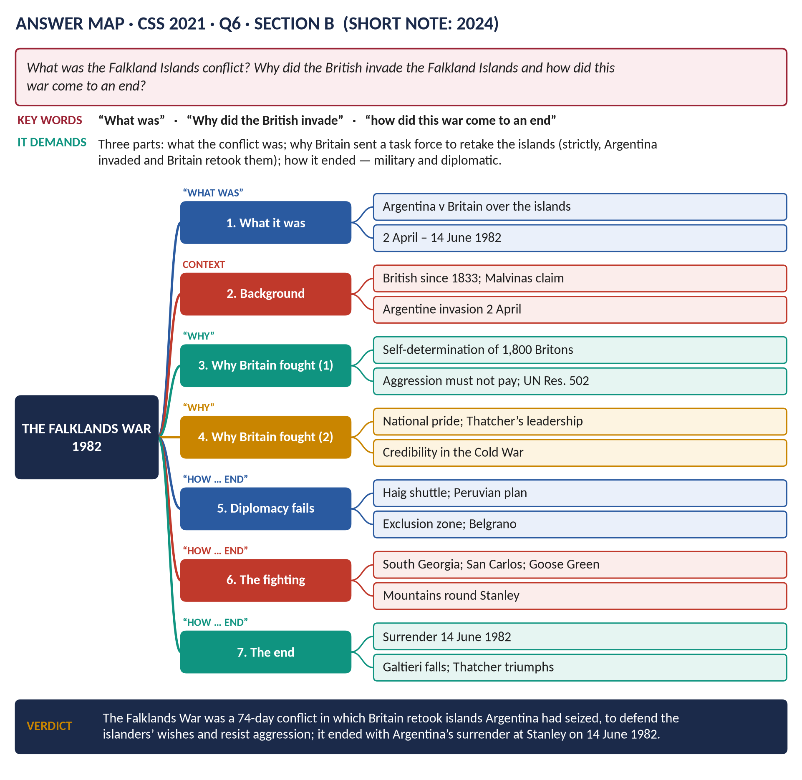
Figure 6 · The answer map for CSS 2021 · Q6 · Section B: every branch is one heading of the answer below.
DECODING THE QUESTION
Three parts. (1) "What was the Falkland Islands conflict?" — a clear description. (2) "Why did the British invade the Falkland Islands?" — note that Argentina invaded first; Britain sent forces to retake them — then give Britain's reasons. (3) "How did this war come to an end?" — the failed diplomacy, the military campaign and the surrender, plus the immediate aftermath.

The model answer

Introduction
The Falkland Islands conflict was a short war — 74 days, from 2 April to 14 June 1982 — between Argentina and Britain over the Falkland Islands, a British territory in the South Atlantic that Argentina calls Las Malvinas. Argentina seized the islands; Britain sent a naval task force 8,000 miles to recover them. Strictly, Britain did not "invade" but retook the islands, to defend the islanders' right to remain British and to show that aggression would not pay. The war ended with Argentina's surrender at Stanley on 14 June 1982.

Part 1 · What was the conflict?

(1) The islands and the dispute
- About 500 km off Argentina; about 1,800 inhabitants of British descent; capital Stanley.
- British since 1833; Argentina has always claimed them.
- Negotiations since 1965 (UN Resolution 2065) failed because the islanders refused Argentine rule.

(2) The Argentine invasion
- The military junta of General Galtieri, facing economic crisis and unpopularity, decided on a quick, popular victory.
- 19 March 1982: Argentine workers raised their flag on South Georgia.
- 2 April 1982: Argentine forces landed near Stanley (Operation Rosario); the 68 Royal Marines surrendered. South Georgia fell on 3 April.

(3) The two sides
- Argentina: about 10,000 troops on the islands; air force with French Exocet missiles and US-built Skyhawks.
- Britain: a task force of about 100 ships (the carriers Hermes and Invincible), some 28,000 men; Harrier jets.

Part 2 · Why Britain sent forces to retake the islands

(4) Self-determination
The islanders were British by birth and wished to remain so. Thatcher: "The people of the Falkland Islands … are British … and their allegiance is to the Crown."

(5) International law — aggression must not pay
The invasion was an armed seizure of territory. The UN Security Council passed Resolution 502 (3 April) demanding Argentine withdrawal. If Britain accepted the invasion, other aggressors would be encouraged.

(6) National pride and credibility
Surrender would have been a humiliation for a country that had lost an empire; it would have damaged Britain's standing as a NATO power in the Cold War.

(7) Political pressure and leadership
- An emergency Commons debate (Saturday 3 April) demanded action; Lord Carrington, the Foreign Secretary, resigned (5 April).
- Thatcher's conviction and her government's survival were at stake.

(8) It was militarily possible
The navy's chiefs (Admiral Leach) assured her that a task force could retake the islands.

Part 3 · How the war came to an end

(9) Diplomacy fails (April–May)
- Alexander Haig, the US Secretary of State, shuttled between London and Buenos Aires; the junta refused to withdraw. On 30 April the USA came down on Britain's side, providing intelligence, fuel and missiles.
- The EEC imposed sanctions on Argentina; the Commonwealth mostly supported Britain.
- A Peruvian peace plan collapsed after the sinking of the Belgrano (2 May).
- The UN Secretary-General's efforts failed (May).

(10) The war at sea and in the air
- A 200-mile Exclusion Zone (April).
- South Georgia retaken (25 April).
- 2 May: the submarine Conqueror sank the cruiser General Belgrano — 323 dead. The Argentine navy stayed in port for the rest of the war.
- 4 May: HMS Sheffield hit by an Exocet; later Ardent, Antelope, Coventry and the Atlantic Conveyor were sunk by air attack.

(11) The land campaign
- 21 May: landings at San Carlos on East Falkland.
- 28 May: 2 Para captured Goose Green.
- Marines and paratroopers "yomped" across East Falkland to the mountains around Stanley.
- 8 June: the Sir Galahad was bombed at Bluff Cove — about 50 dead.
- 11–14 June: night battles for Mount Longdon, Mount Tumbledown and Wireless Ridge.

(12) The surrender
On 14 June 1982 General Mario Menéndez surrendered his forces at Stanley; about 11,000 Argentine prisoners were returned home.
Casualties | Numbers
British servicemen | 255
Argentine servicemen | 649
Falkland islanders | 3

(13) The immediate aftermath
- Argentina: Galtieri was forced out (17 June); the junta collapsed; democracy returned (Alfonsín, 1983).
- Britain: Thatcher's popularity soared — the "Falklands factor" in her 1983 landslide; the Franks Report (1983) on the causes; full British citizenship for the islanders (1983); a permanent garrison (Mount Pleasant, 1985).
- The dispute was not settled: Argentina maintains its claim.
VERDICT · Conclusion
The Falklands conflict was a 74-day war in 1982 in which Britain recovered islands that Argentina's military junta had seized. Britain fought to defend the islanders' wish to remain British, to uphold international law against aggression, and to protect its national pride and credibility. After diplomacy failed, the war was decided by the sinking of the Belgrano, the landings at San Carlos and the battles around Stanley, and it ended with Argentina's surrender on 14 June 1982 — bringing down the junta and restoring democracy in Argentina, and strengthening Thatcher at home.

WHY THIS ANSWER SCORES · Why this answer scores
Three parts, three sections · it corrects the question's wording politely ("retook", not "invaded") — showing precise knowledge · reasons for British action are numbered · the end covers diplomacy, sea, land and surrender with dates and casualties · the aftermath completes "how it ended".

Answer 6 · Why Major Won in 1992 but Lost in 1997
THE QUESTION · CSS 2019 · Q8 · Section B · 20 marks
Explain why John Major and the Conservatives won the general election of 1992 but lost the election of 1997.

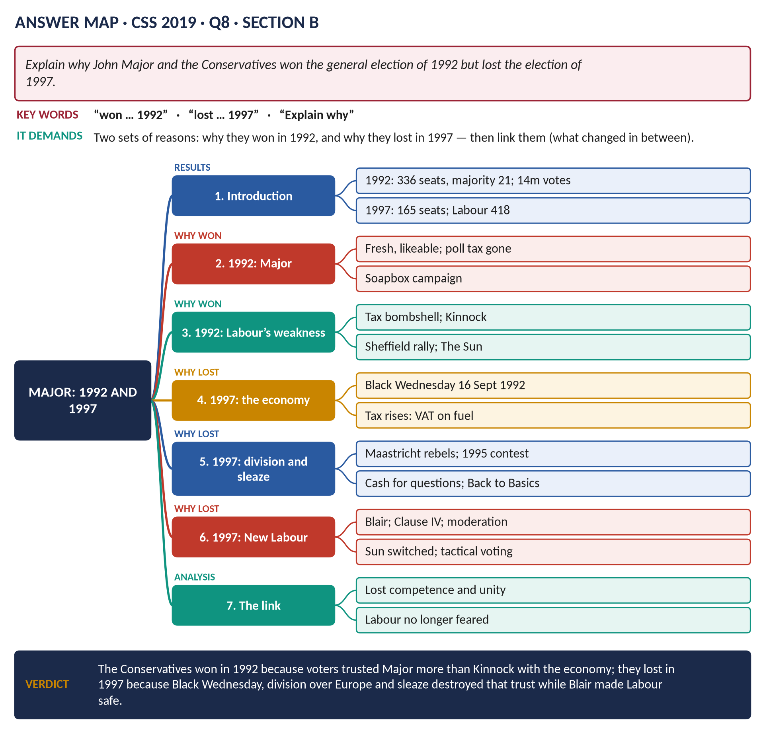
Figure 7 · The answer map for CSS 2019 · Q8 · Section B: every branch is one heading of the answer below.
DECODING THE QUESTION
"Explain why" two opposite results: the Conservative victory of April 1992 and their defeat of May 1997. Give reasons for each, grouped, and then link them — what changed between 1992 and 1997?

The model answer

Introduction
John Major became Prime Minister in November 1990 after Margaret Thatcher's fall. Against most predictions, he won the general election of 9 April 1992, with a majority of 21 and about 14 million votes — the largest number ever won by a British party. Five years later, on 1 May 1997, the Conservatives suffered their worst defeat since 1906, reduced to 165 seats against Labour's 418. The Conservatives won in 1992 because voters trusted them — and Major — more than Labour on the economy; they lost in 1997 because Black Wednesday, division over Europe and sleaze destroyed that trust, while Tony Blair's "New Labour" made Labour safe to vote for.
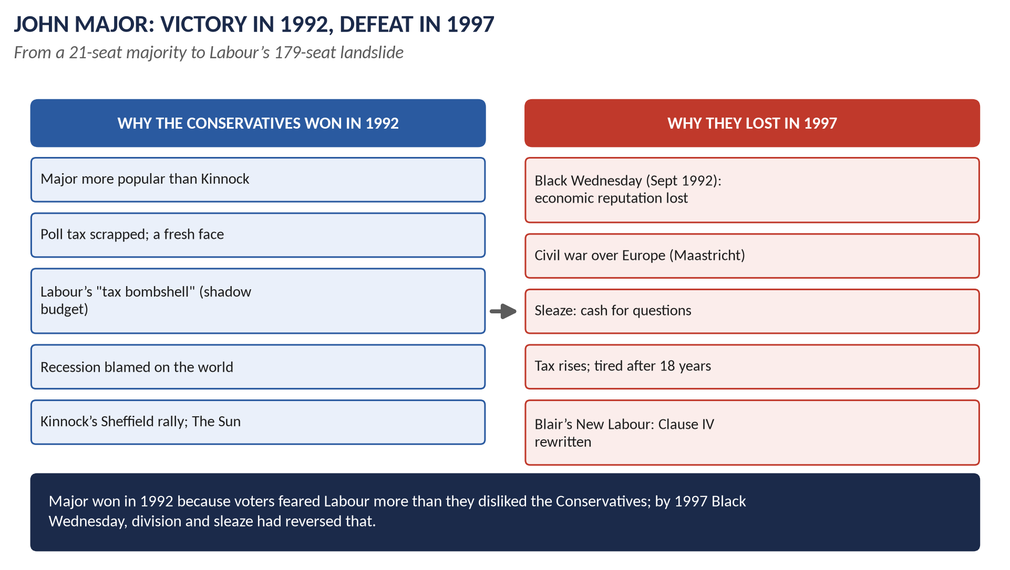
Figure 8 · 1992 and 1997.

Why the Conservatives won in 1992

(1) A new leader
- Major was modest, likeable and seen as a fresh start after Thatcher; his "soapbox" campaign (speaking from a box in town centres) gave him a common touch.
- He had removed the hated poll tax (replaced by the Council Tax) and led Britain through the successful Gulf War (1991).

(2) Fear of Labour's taxes
- Labour's Shadow Chancellor John Smith published a "shadow budget" with higher taxes on the better-off.
- The Conservatives' campaign — "Labour's Tax Bombshell" and "Double Whammy" (higher taxes and higher prices) — persuaded many middle-income voters that they would pay more.

(3) Doubts about Neil Kinnock
- Voters did not see Kinnock as a Prime Minister; his over-confident Sheffield rally (1 April) looked triumphalist.
- The popular press, led by The Sun, attacked him ("If Kinnock wins today will the last person to leave Britain please turn out the lights"); afterwards it boasted "It's The Sun Wot Won It".

(4) Economic trust
Although Britain was in recession, voters blamed world conditions and still trusted the Conservatives more than Labour to manage the economy — memories of the 1970s and of Labour's divisions in the 1980s remained.

(5) The "shy Tories"
Opinion polls showed a Labour lead; many Conservative voters did not admit their intentions — the pollsters' failure hid the Conservatives' real support.

Why the Conservatives lost in 1997

(6) Black Wednesday — the loss of economic credibility
- On 16 September 1992, only five months after the election, speculators forced the pound out of the ERM; the government raised interest rates to 15 per cent in a day and spent billions of reserves, but failed.
- The Conservatives lost their reputation for economic competence at once and never regained it, even though the economy then grew steadily with falling unemployment and inflation.

(7) Broken promises on tax
To close the budget deficit, the government raised taxes — including VAT on domestic fuel and power (1994) — despite its 1992 campaign against Labour's tax rises.

(8) Division over Europe
- The Maastricht Treaty: Conservative rebels fought the bill in 1992–93; Major needed a vote of confidence to pass it (July 1993).
- Major was heard calling three Eurosceptic cabinet ministers "bastards" (1993); the whip was withdrawn from eight rebel MPs (1994).
- In 1995 he resigned the party leadership, telling his critics to "put up or shut up"; he beat John Redwood, but the party remained divided.
- The Referendum Party (Sir James Goldsmith) and UKIP took Eurosceptic votes in 1997.

(9) Sleaze
- "Cash for questions" (1994): MPs (including Neil Hamilton) had taken money to ask parliamentary questions.
- Jonathan Aitken sued a newspaper and was later jailed for perjury.
- Sexual scandals made Major's "Back to Basics" campaign (1993) look hypocritical.
- The Nolan Committee on standards in public life (1994) was set up.

(10) Other problems
- The BSE ("mad cow") crisis (1996) and the European ban on British beef.
- Unpopular rail privatisation.
- A weak-looking leader; a narrow and shrinking majority.
- Time for a change: 18 years of Conservative government.

(11) New Labour
- Tony Blair became Labour leader in 1994 after John Smith's death.
- He rewrote Clause IV (1995), dropping the commitment to nationalisation, and renamed the party "New Labour".
- He promised not to raise income tax, to keep Conservative spending limits for two years, and to be tough on crime.
- He won over business and The Sun (which backed Labour in 1997).
- Tactical voting between Labour and Liberal Democrat supporters removed many Conservative MPs.

Linking the two elections
Factor | 1992 | 1997
Economic trust | Conservatives trusted | Lost on Black Wednesday
Taxes | "Labour's tax bombshell" | Conservative tax rises; Labour promised no rise
Party unity | Fairly united behind Major | Civil war over Europe
Reputation | Fresh leader | Sleaze; tired
The opposition | Kinnock distrusted | Blair trusted; New Labour moderate
The press | The Sun for Major | The Sun for Blair

VERDICT · Conclusion
The Conservatives won in 1992 because Major was more trusted than Kinnock, because voters feared Labour's taxes, and because they still trusted the Conservatives with the economy. By 1997 every one of these advantages had been reversed: Black Wednesday destroyed their economic reputation, their own tax rises undermined their attacks on Labour, Europe split the party, sleaze disgraced it, and Tony Blair made Labour look moderate and safe. The result was the largest Conservative defeat for ninety years.

WHY THIS ANSWER SCORES · Why this answer scores
Reasons for 1992 and reasons for 1997 in separate, numbered groups · specific evidence (Tax Bombshell, Black Wednesday, "put up or shut up", cash for questions, Clause IV) · a linking table explains what changed — the "why" behind both results.

Answer 7 · Britain's Contribution to the Common Market and the European Union
THE QUESTION · CSS 2021 · Q7 · Section B · 20 marks
What was the contribution of Great Britain to the formation of the European Common Market and the European Union? Also highlight its impact on the foreign policy of Britain.

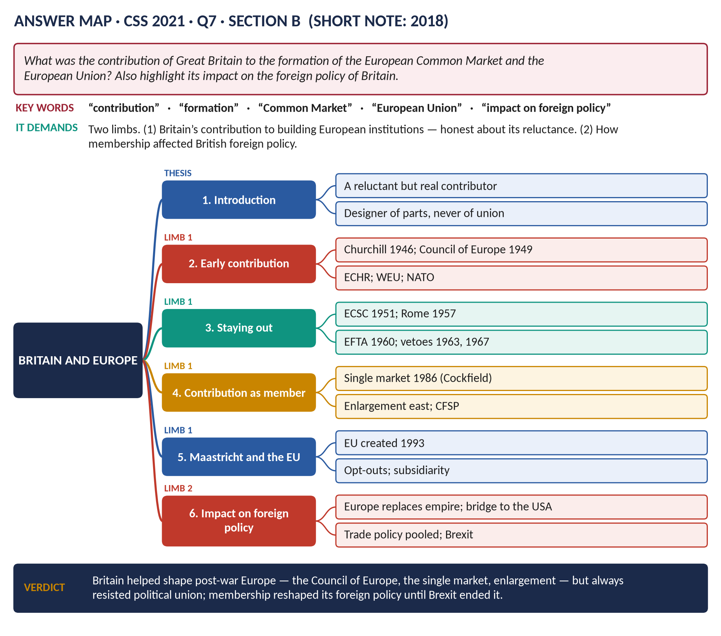
Figure 9 · The answer map for CSS 2021 · Q7 · Section B: every branch is one heading of the answer below.
DECODING THE QUESTION
Two limbs. (1) "What was the contribution of Great Britain to the formation of the European Common Market and the European Union?" — what Britain did to create or shape these institutions (be honest: it stayed out of the Common Market's founding). (2) "Also highlight its impact on the foreign policy of Britain" — how membership (1973–2020) changed British foreign policy.

The model answer

Introduction
Britain's contribution to European integration is a paradox. It inspired the post-war idea of a united Europe (Churchill, 1946) and helped build the Council of Europe and the European Convention on Human Rights, but it refused to join the founding of the European Common Market (EEC, 1957). Once a member (from 1973), it made major contributions — above all the single market (1986) and the enlargement of the Union to the east — and it helped shape the Maastricht Treaty (1992) that created the European Union, while securing opt-outs from its most ambitious parts. Membership transformed British foreign policy: Europe replaced the empire as Britain's main framework, and Britain became a "bridge" between the USA and Europe — until Brexit (2020).
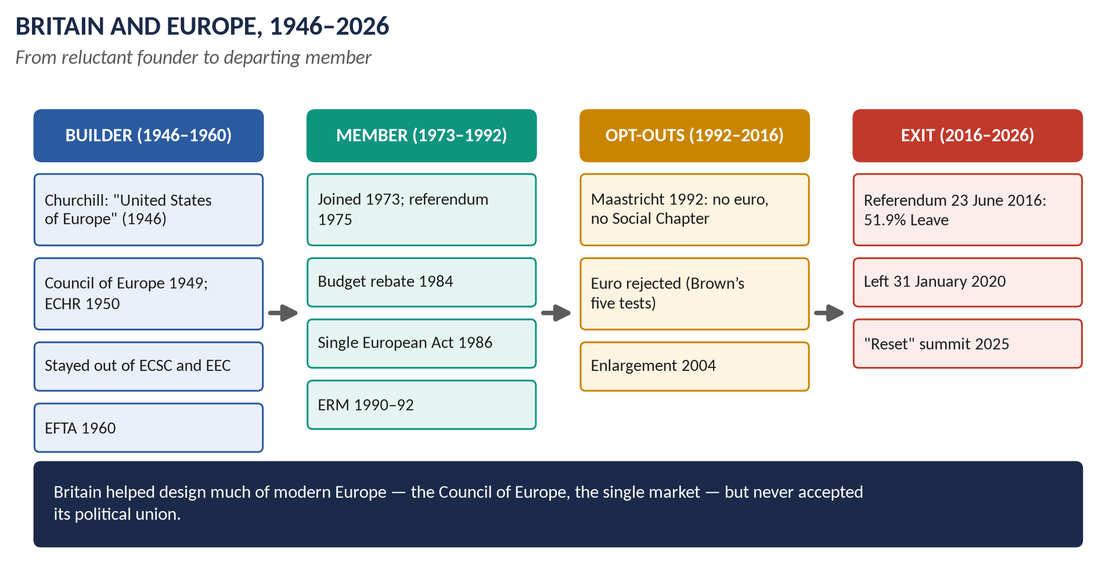
Figure 10 · Britain and Europe, 1946–2026.

Limb 1 · Britain's contribution

(1) Inspiration and early building (1946–1955)
- Churchill's Zurich speech (1946) called for "a kind of United States of Europe" built on Franco-German reconciliation — one of the founding visions of European unity.
- Ernest Bevin led Western Europe's response to the Marshall Plan (the OEEC, 1948) and built the Brussels Treaty (1948) and NATO (1949).
- The Council of Europe (1949): Britain was a founding member (Treaty of London).
- The European Convention on Human Rights (1950): drafted largely by British lawyers (David Maxwell Fyfe).
- The Western European Union (1954): Eden's plan allowed West German rearmament within Western Europe.

(2) Standing aside from the Common Market (1950–1972)
- Britain refused to join the European Coal and Steel Community (1951) and the Messina talks that led to the Treaty of Rome (1957), which created the EEC — because of the Commonwealth, the USA, national sovereignty, and confidence in its own strength.
- It formed EFTA (1960) as a looser free-trade alternative.
- Its later applications (1961, 1967) were vetoed by de Gaulle.
- So Britain made no direct contribution to the founding of the Common Market — a decision many historians regard as a mistake ("missing the bus").

(3) Contributions as a member (1973–1992)
- Entry (1 January 1973) with Ireland and Denmark enlarged the Community; the 1975 referendum (67 per cent) confirmed it.
- Regional policy: Britain pressed for the European Regional Development Fund (1975).
- Budget reform: Thatcher's rebate (Fontainebleau, 1984) forced reform of the Community's finances.
- The single market — Britain's greatest contribution: the Single European Act (1986) and the programme to remove barriers to trade in goods, services, capital and people by 1992, designed by the British commissioner Lord Cockfield.
- Enlargement: Britain championed the entry of Greece (1981), Spain and Portugal (1986) and, after the Cold War, the new democracies of Central and Eastern Europe (achieved 2004).
- Foreign-policy cooperation: Britain was a leading voice in European Political Cooperation (from 1970).

(4) Maastricht and the creation of the European Union (1991–1993)
- Major negotiated the Maastricht Treaty (December 1991), which created the European Union (1 November 1993) with three "pillars": the European Community; a Common Foreign and Security Policy; cooperation in justice and home affairs.
- Britain's contributions: the pillar structure, keeping foreign policy and justice intergovernmental; the principle of subsidiarity; stronger powers for the Court of Auditors.
- Britain's opt-outs: from the single currency and the Social Chapter.

(5) Later contributions (1997–2016)
- Blair signed the Social Chapter (1997).
- European defence: the St Malo Declaration (1998) with France launched the EU's defence policy.
- Enlargement (2004, 2007) and the Lisbon Treaty (2007).
- Leadership on climate change, sanctions on Iran and Russia, development aid.

Limb 2 · The impact on British foreign policy

(6) From empire to Europe
Membership replaced the Commonwealth as Britain's main economic and diplomatic framework; trade with Europe rose to about half of Britain's total. It answered Acheson's jibe that Britain had "lost an empire and not yet found a role".

(7) A bridge between America and Europe
Britain used its special relationship with the USA to gain influence in Europe, and its EU membership to gain influence in Washington. But the bridge could be strained — above all over Iraq (2003), when Blair sided with the USA against France and Germany.

(8) Pooled powers
Trade policy was handed to the EU, which negotiated trade deals for all members; foreign policy increasingly worked through common positions and sanctions.

(9) The "awkward partner"
Britain resisted federalism, secured opt-outs (the euro, the Social Chapter, Schengen), fought over the budget and often found itself isolated — Stephen George's "awkward partner".

(10) After Brexit (2020–2026)
- "Global Britain": independent trade deals (Australia, New Zealand, Japan), joining the CPTPP (2023), the AUKUS pact (2021), a "tilt" to the Indo-Pacific.
- Close cooperation with Europe over Ukraine (from 2022), and a "reset" under Starmer — the May 2025 summit agreed a security and defence partnership.
VERDICT · Conclusion
Britain's contribution to European integration was real but selective: it inspired the post-war vision, built the Council of Europe and the Human Rights Convention, stayed out of the Common Market's founding, and then, as a member, gave the Community its single market, drove its enlargement and shaped the Maastricht Treaty that created the European Union — while opting out of its deepest integration. Membership turned British foreign policy from empire to Europe and made Britain a bridge across the Atlantic, but its reluctance to accept political union finally led it out of the Union in 2020.

WHY THIS ANSWER SCORES · Why this answer scores
It is honest about the paradox — Britain did not help found the EEC — which examiners reward · the contributions are specific (ECHR, single market/Cockfield, enlargement, Maastricht's pillars and subsidiarity, St Malo) · Limb 2 covers the impact from 1973 to Brexit and after · a balanced verdict.

Answer 8 · European Integration and British Politics and Identity since 1973
THE QUESTION · CSS 2026 · Q6 · Section B · 20 marks
Discuss the impact of European integration on British politics and identity since 1973, with particular reference to the debates surrounding the Maastricht Treaty and the UK's opt-out from the euro.

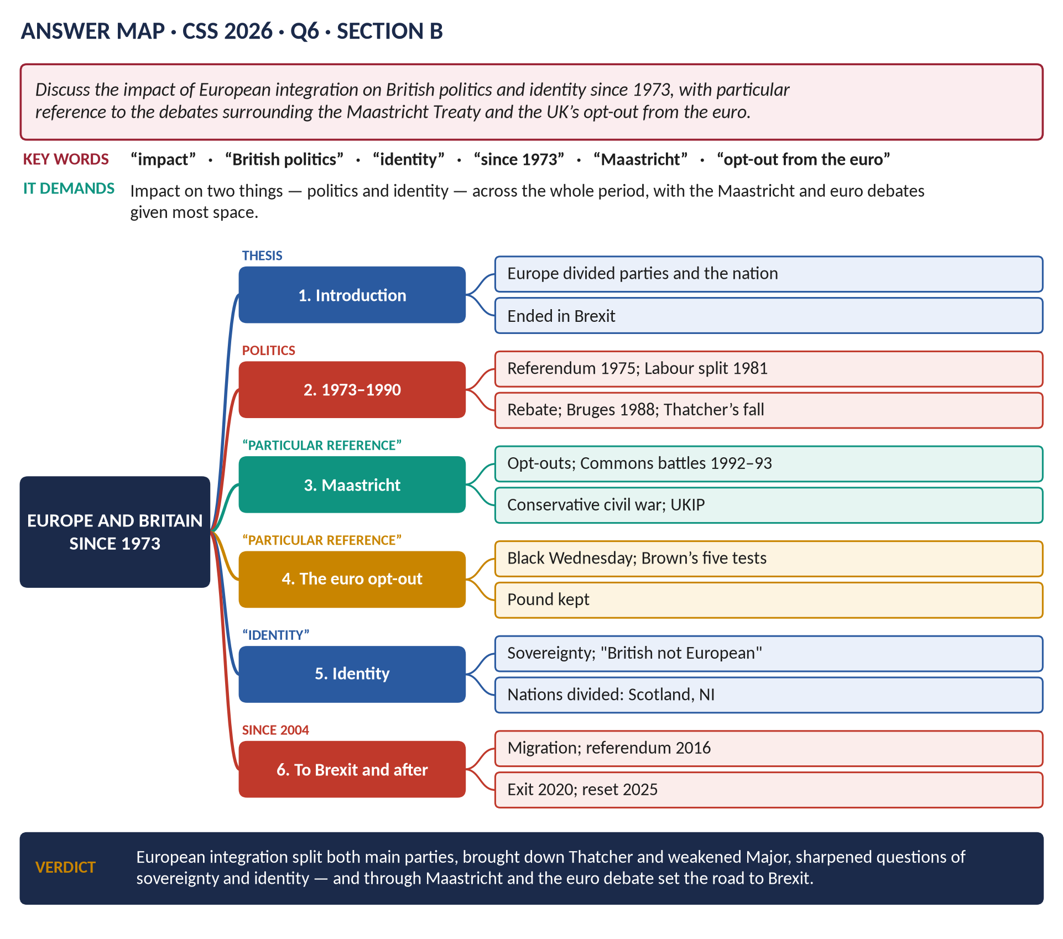
Figure 11 · The answer map for CSS 2026 · Q6 · Section B: every branch is one heading of the answer below.
DECODING THE QUESTION
"Discuss the impact of European integration on British politics and identity since 1973" — two things affected: politics (parties, leaders, Parliament, elections, referendums) and identity (how the British see themselves — British, English, Scottish, European; sovereignty). "With particular reference to the debates surrounding the Maastricht Treaty and the UK's opt-out from the euro" — these two debates must have the most space. Cover the whole period to the present.

The model answer

Introduction
Since Britain joined the European Community on 1 January 1973, European integration has been the most divisive question in British politics. It split both major parties, brought down or broke several Prime Ministers, created new parties, introduced national referendums, and raised deep questions about sovereignty and identity — whether the British saw themselves as Europeans at all. The debates over the Maastricht Treaty (1992) and the single currency were the turning point: they turned Conservative doubts into open civil war, made Euroscepticism a mass movement, and set Britain on the road to Brexit (2016–2020).

Politics, 1973–1990

(1) Labour's divisions
- Labour was split over membership: Wilson held the 1975 referendum (67 per cent Yes) with ministers campaigning on both sides.
- In 1983 Labour promised to leave the EEC; its pro-European right had already broken away to form the SDP (1981).

(2) Thatcher and Europe
- The rebate (1984) and the Single European Act (1986) — she supported the single market, but not a political union.
- The Bruges speech (1988) rejected "a European super-state" and inspired Conservative Eurosceptics.
- Disagreement over the ERM and European union led to the resignations of Lawson (1989) and Howe (1990), and to her fall (November 1990).

(3) Sovereignty in law
The Factortame case (1990) showed that EU law could override an Act of Parliament — a direct challenge to the traditional idea of parliamentary sovereignty.

The Maastricht debates (1991–1993)

(4) What Maastricht did
The Maastricht Treaty (agreed December 1991, signed February 1992) created the European Union: a timetable for economic and monetary union (the single currency), a Common Foreign and Security Policy, cooperation in justice and home affairs, and European citizenship.

(5) Major's opt-outs
John Major secured opt-outs from the single currency and the Social Chapter, and the principle of subsidiarity — his team called it "game, set and match".

(6) The ratification crisis
- Denmark's "No" vote (June 1992) and Black Wednesday (September 1992) strengthened opponents.
- A group of Conservative "Maastricht rebels" (about 20–40 MPs) voted repeatedly against the bill; Labour opposed the opt-out from the Social Chapter.
- Major lost a key vote and had to call a vote of confidence (July 1993) to pass the treaty.
- The fight damaged his authority permanently: the "bastards" remark (1993), the whip withdrawn from eight rebels (1994), and the "put up or shut up" leadership election (1995).

(7) New Eurosceptic politics
- UKIP was founded (1993) to take Britain out of the EU.
- The Referendum Party (Goldsmith, 1994–97) won about 800,000 votes in 1997.
- The Conservatives' divisions helped Labour's landslide (1997).

The euro opt-out

(8) Black Wednesday and the euro
- The pound's forced exit from the ERM (16 September 1992) made monetary union politically toxic: many voters linked European monetary integration with economic humiliation.

(9) Blair and Brown
- Blair favoured joining the euro in principle, but Gordon Brown set five economic tests (October 1997) — on convergence, flexibility, investment, the City and jobs.
- The euro was launched in 1999 (notes and coins in 2002) without Britain; the Treasury's assessment (2003) found the tests not met; the idea was dropped.

(10) Why the opt-out mattered
- It kept the pound — a powerful symbol of national identity and sovereignty (the Bank of England, the Queen's head on the notes).
- It kept Britain outside the core of the EU, especially after the euro crisis (2010–12) made the eurozone integrate further — making Britain feel a second-class member and strengthening the case that it was different.

From Maastricht to Brexit (2004–2020)

(11) The road to the referendum
- Enlargement (2004) and free movement brought large-scale immigration from Eastern Europe — making immigration central to the European debate.
- The Lisbon Treaty (2007) was ratified without a referendum, angering Eurosceptics.
- UKIP won the European elections (2014); Cameron promised a referendum (Bloomberg speech, 2013).
- The referendum (23 June 2016): 51.9 per cent Leave. Cameron resigned; Theresa May fell over her Brexit deal (2019); Boris Johnson took Britain out on 31 January 2020.

The impact on identity

(12) "British, not European"
- Surveys consistently found that the British, especially the English, had one of the weakest European identities in the EU; most described themselves as "British only".
- Island geography, a history of empire and victory in two world wars, a common-law tradition and the special relationship with the USA all set Britain apart.

(13) Sovereignty
The argument that decisions should be made by the British Parliament, not in Brussels, ran from Bruges (1988) through Maastricht to "Take Back Control" (2016).

(14) A divided nation
- The nations: Scotland (62 per cent Remain) and Northern Ireland (56 per cent Remain) felt more European than England; Brexit strengthened Scottish nationalism and complicated the Irish border (the Protocol, the Windsor Framework, 2023).
- Generations, education and places: the young, graduates and big cities were pro-European; older voters and post-industrial towns voted Leave — the "left behind".

Summary of the impact
Area | Impact
Parties | Labour split (1975–83, SDP 1981); Conservative civil war (1990s, 2016–19); UKIP, Referendum Party, Brexit Party / Reform UK
Leaders | Thatcher's fall (1990); Major's authority broken; Cameron (2016) and May (2019) brought down
Constitution | Referendums (1975, 2016); Factortame and EU law; devolution tensions
Identity | "British not European"; sovereignty; the nations divided; age and place divides

VERDICT · Conclusion
European integration has shaped British politics and identity more than any other issue since 1973. It split both major parties and destroyed or weakened four Prime Ministers; through Maastricht it turned Conservative unease into civil war and gave birth to UKIP; through the euro opt-out it kept the pound as a symbol of national sovereignty and left Britain outside Europe's core. Because most British people never came to see themselves as Europeans, these debates led, step by step, to the vote to leave in 2016 — and even after Brexit the question of Britain's relationship with Europe remains unsettled.

WHY THIS ANSWER SCORES · Why this answer scores
It covers both politics and identity across the whole period · Maastricht and the euro have the most space, as "particular reference" demands, with dates and details · the link from Maastricht to Brexit is explained · a summary table · a clear verdict.

Short Notes

Britain's Role in the European Union
THE QUESTION · CSS 2018 · Q8(b) · Section B · short note (10 marks)
Write a short note on: Britain's role in the EU

- Before membership: Churchill's call for a "United States of Europe" (1946); a founder of the Council of Europe (1949) and the European Convention on Human Rights (1950); stayed out of the EEC (1957); EFTA (1960); vetoed by de Gaulle (1963, 1967).
- Member from 1 January 1973; the 1975 referendum (67 per cent Yes).
- Contributions: the single market (Single European Act 1986, designed by Lord Cockfield); enlargement to Southern and Eastern Europe (2004); the budget rebate (1984); subsidiarity and the pillar structure at Maastricht (1992); European defence (St Malo, 1998); climate change, sanctions, aid.
- An "awkward partner": opt-outs from the euro, the Social Chapter (until 1997) and Schengen; hostility to federalism (Bruges, 1988); the ERM exit (1992).
- A bridge between the EU and the USA; one of the "big three" with France and Germany; a permanent member of the UN Security Council within the EU.
- Exit: the 2016 referendum (51.9 per cent Leave); Britain left on 31 January 2020; the Trade and Cooperation Agreement (2020); the Windsor Framework (2023); a "reset" in 2025.
In one line: a major but reluctant member that shaped the single market and enlargement, resisted political union, and finally left.

The Falklands War (1982)
THE QUESTION · CSS 2024 · Q7(a) · Section B · short note (10 marks)
Write a short note on: Falkland War

- What: a 74-day war (2 April – 14 June 1982) between Argentina and Britain over the Falkland Islands (Las Malvinas), a British territory since 1833 with about 1,800 British inhabitants.
- Causes: the old sovereignty dispute; British signals of weakness (the withdrawal of HMS Endurance, the 1981 Nationality Act); the unpopular junta of General Galtieri seeking a patriotic victory; the belief that Britain would not fight.
- Invasion: Argentina seized the islands on 2 April; UN Resolution 502 demanded withdrawal; Lord Carrington resigned; a task force sailed.
- War: US mediation (Haig) failed; South Georgia retaken (25 April); the General Belgrano sunk (2 May, 323 dead); HMS Sheffield sunk (4 May); landings at San Carlos (21 May); Goose Green (28 May); the mountains around Stanley.
- End: Argentine surrender at Stanley (14 June 1982). Dead: 255 British, 649 Argentines, 3 islanders.
- Results: Galtieri fell and democracy returned to Argentina (1983); Thatcher's popularity soared ("Falklands factor", 1983 landslide); relations with Argentina broken until 1990; the dispute continues (99.8 per cent of islanders voted to stay British in 2013).
In one line: a short, decisive war that restored British rule, toppled Argentina's junta and secured Thatcher's dominance.

John Major's Foreign Policy (1990–1997)
THE QUESTION · CSS 2026 · Q8(c) · Section B · short note (10 marks)
Write a short note on: John Major's foreign policy

- The Gulf War (1991): about 45,000 British troops in the US-led coalition that liberated Kuwait; Major proposed safe havens for the Kurds in northern Iraq and supported the no-fly zones.
- Europe: aimed to put Britain "at the very heart of Europe"; at Maastricht (1991) won opt-outs from the single currency and the Social Chapter, and the principle of subsidiarity; Black Wednesday (1992) forced Britain out of the ERM; party divisions and the beef war (BSE, 1996) weakened his European policy.
- The Balkans: British troops in the UN force (UNPROFOR) in Bosnia (1992–95); criticised for caution (opposing arms for the Bosnians) until Dayton (1995).
- Northern Ireland: the Downing Street Declaration (December 1993) with Albert Reynolds; the IRA ceasefire (August 1994) — foundations of the Good Friday Agreement.
- The USA: close with George H. W. Bush; tensions with Bill Clinton over Bosnia and Gerry Adams's visa (1994).
- After the Cold War: support for Yeltsin's Russia; defence cuts; peacekeeping.
- Hong Kong: Chris Patten's democratic reforms angered China; handover prepared for 1 July 1997.
In one line: a cautious, constructive foreign policy — successful in the Gulf and Northern Ireland, constrained by Europe and Bosnia.

Part Two — The Past MCQs, Solved

CSS 2024 · MCQ 9
Who succeeded Margaret Thatcher as Prime Minister?
(A) Cullodena Newcomen | (B) James Callaghan | (C) Thomas Cuddodin | (D) None of these

REMEMBER · Answer: D. None of these — John Major
John Major succeeded Margaret Thatcher on 28 November 1990 after winning the Conservative leadership election. The names in the options are not real Prime Ministers (and Callaghan preceded Thatcher), so the key is "None of these".

CSS 2025 · MCQ 14
Which Prime Minister is most closely associated with large-scale privatisation of British industries?
(A) Margaret Thatcher | (B) Tony Blair | (C) John Major | (D) None of these

REMEMBER · Answer: A. Margaret Thatcher
Margaret Thatcher is the Prime Minister most associated with privatisation — British Telecom (1984), British Gas (1986), British Airways (1987), water (1989), electricity (1990).

CSS 2025 · MCQ 19
Which group led the major 1984–85 industrial action?
(A) Miners | (B) Dockworkers | (C) Train drivers | (D) None of these

REMEMBER · Answer: A. Miners
The great strike of 1984–85 was led by the miners (the NUM under Arthur Scargill) against pit closures; it ended in defeat in March 1985.

CSS 2026 · MCQ 10
Britain’s first female Prime Minister belonged to which party?
(A) Liberal | (B) Labour | (C) Conservative | (D) None of these

REMEMBER · Answer: C. Conservative
Britain's first woman Prime Minister, Margaret Thatcher, led the Conservative Party.

Part Three — Five Predicted Questions, with Outlines
WHAT THE EXAMINER HAS ASKED · Why these five
They cover parts of syllabus Head XIV not yet set as full questions.

Predicted 1 · "Discuss the causes, course and consequences of the miners' strike of 1984–85."
- Causes: pit closures; Thatcher's aim to break union power; Scargill's politics; memories of 1972–74.
- Course: no national ballot; Nottinghamshire worked on; Orgreave; policing; hardship; the NCB's coal stocks.
- Consequences: defeat; closures; the end of union power; ruined communities; the Union of Democratic Mineworkers.

Predicted 2 · "Why did Margaret Thatcher fall from power in 1990?"
- Poll tax and riots; economic problems (inflation, interest rates); Europe (Lawson, Howe); her style; Heseltine's challenge; cabinet advice; her resignation.

Predicted 3 · "Assess Thatcher's foreign policy, with reference to the USA, the Soviet Union and Europe."
- USA: Reagan; cruise missiles; Libya; Grenada. USSR: the Iron Lady; Gorbachev; the end of the Cold War. Europe: the rebate; the single market; Bruges. Others: Falklands; Hong Kong; South Africa.

Predicted 4 · "Trace the Northern Ireland peace process from 1979 to 1998."
- Hunger strikes 1981; Brighton 1984; Anglo-Irish Agreement 1985; Downing Street Declaration 1993; ceasefire 1994; Mitchell principles; Good Friday Agreement 1998.

Predicted 5 · "How far did Thatcherism end the post-war consensus?"
- The consensus: welfare state, full employment, mixed economy, union partnership.
- What changed: monetarism (not full employment); privatisation; union laws; tax.
- What survived: the NHS; the welfare state (spending grew); New Labour's acceptance of her changes.
- Verdict: ended the economic consensus; created a new one.

